CAJUN R/C CLUB GLIDER RULES
NEW IBERIA, LA
for more information go to cajunrcclub.com

1. The wingspan of the glider shall not exceed two meters, and must be greater than 1½ meters. There is no restriction on the chord or wing area.
2. There is no weight limitation, and it is expected three servos will be used, one on elevator, one on the rudder, and one on the throttle.
3. The gliders will be powered by a glow engine with a displacement no greater than .061 cu. in. It may be mounted on the nose, or on a pod attached to the glider. The engine must be stopped upon command by the timer. The pilot must demonstrate this on the ground before the first flight.
4. Timing of all flights will begin at the instant of the release of the glider from the ground. . The engine may be shut off within 30 seconds of the flight if the pilot so desires, and the flight will not count and he will be given another chance. After 30 seconds of flight (after glider is launched), the flight will be counted. Engine run will be 45 seconds. Timing will end when the model contacts the ground or a ground based object, such as a tree, car, or person and comes to a stop.
6. The maximum time for any given flight will be 5 minutes. As this is an experimental set of rules, the CD may change the time to suit the situation until a final set of rules is adopted.
7. A bonus of 100 seconds will be added for each flight if the glider lands in the spot, and 50 seconds will be added if the glider lands inside the outer circle. There will be no penalty if the spot is missed.
8. Scores will be determined as follows:
a) Time for four (4) flights will be added.
b) If more than 4 flights are flown, the highest four will be added.
c) Ribbons will be awarded for first, second and third.
9. At the end of the year, the scores from all glider contests for that year will be added by taking the highest scores from no more than three contests for each contestant. The contestant with the highest total will be the grand champion for the year.
My Comments on this Format

I attended this contest last year and was planning on making their first contest of this year (finger injury stopped me). As you can see from the rules posted above, it is a modified Climb & Glide using smaller engines, shorter engine runs, shorted max times, and you have to make a spot landing to receive extra points. Spot landings are very important. I was the only one to max all flights but missed the spot landings and came in 3rd.
Advantages:
- To make a 5 minute max, the plane does not have to be a speck in the sky. It is great for people with poor vision.
- The climb out is at a safe rate. Less chance of losing control.
- Does not take all day to get required flights in.

The plane my son and I plan to use at the next contest
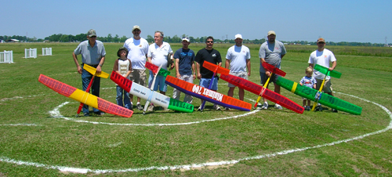
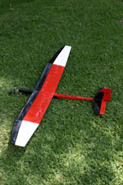
M & M Glider Tech
Illusion w/ extended wing tips

Specs:
Wing Span – 62”
Wing Area – 453.5 in.sq.
Weight – 16.2 oz.
Wing Loading – 5.15
oz/sq.ft.
My plane
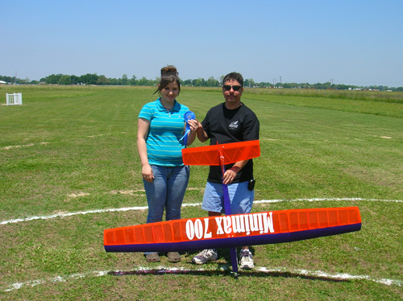

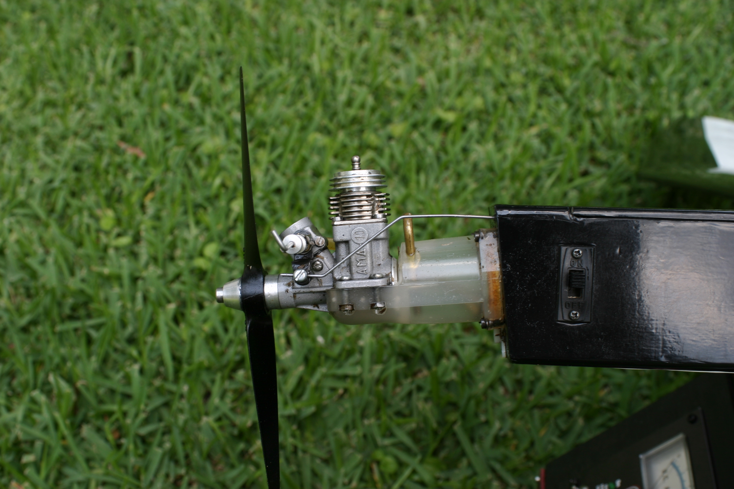

I use a Norvel .049 with RC carb

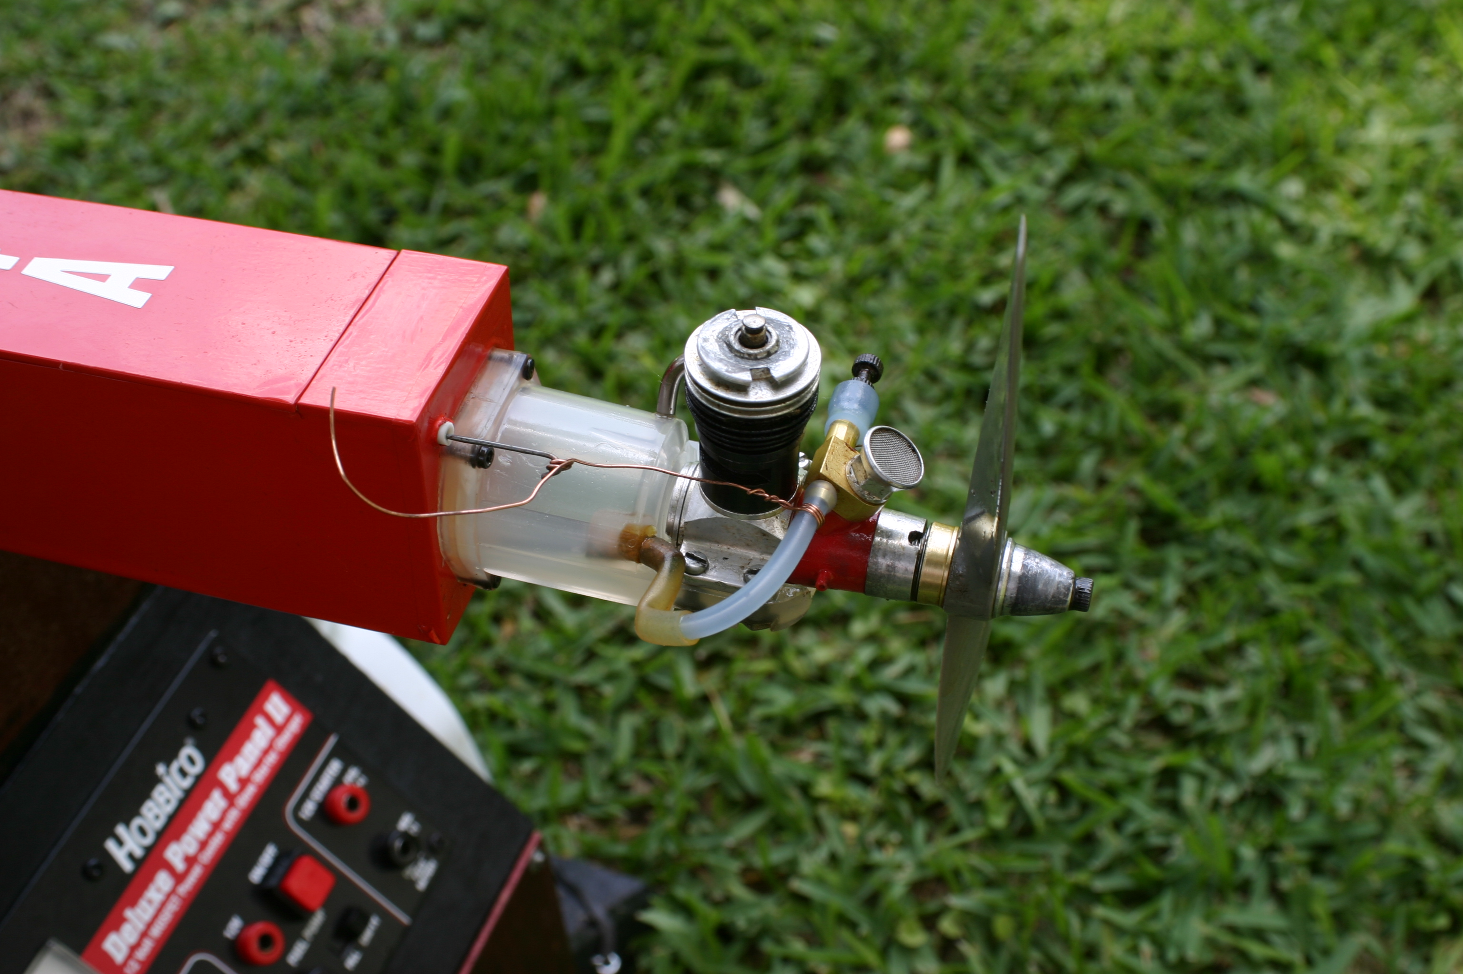
Scott’s has a TD .051 and to shut the engine off, the fuel line has to be pulled off. This is a test setup

Color schemes are very important. We have white on top of wing for easy orientation when the plan is in the climb and black on the underside. Black is easily visible at high altitudes.

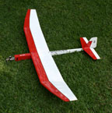
Scott’s plane
Pictures from Cajun RC Club Glider Event 2007
The rings are for spot landings
Kirk Babineaux won first place

Most of the contestants in the Cajun RC Club use 2 meter gliders and .061 engines.

Next contest is June 23, 2007 starting at 10:00am.
If you have any interest in trying out this event, please let me know.

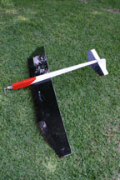
I would also like to work with someone to come up with equivalent electric power so both glow and electric could be used in the same contest. Anyone willing to assist?

Editor – Pat Beard

